# Dielectric Antenna Transferer to New Device.

Contents

Dielectric Antenna Transferer to New Device. 1

Source code location 1

Arduino firmware upload 2

Actuonix 2

RS PRO 3

MiQVNA 4

Hardware connections 4

VTC/PC 4

Arduino 4

VNA 5

Actuator 6

Teltonika 7

VNA Interface changes 7

Download python 7

VNA interface config file changes. 7

Test Run 9

Helpful Trouble shooting information 9

## Source code location

Source code can be found in the team’s folder at in the team group IG88.

In Documents -> General -> 03 Development -> Dielectric Antenna

## Arduino firmware upload

There are two different actuators that are used in this project being the Actuonix and RS PRO (RS PRO being the latest version).

### Actuonix

The firmware for this actuator can be found at

Megiq VNA Server\Python Server\mudmasterui\ArduinoFirmware\MountingSystem

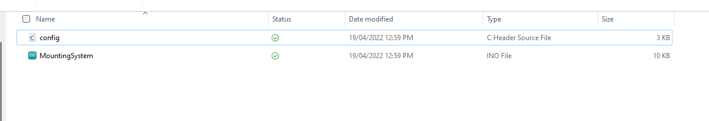

These files are uploaded to the Arduino using the Arduino IDE

Open the mounting system file then click upload with Arduino Uno selected. Should be the only option.

### RS PRO

The firmware for this actuator can be found at

Not yet uploaded to share drives

These files are uploaded to the Arduino using the Arduino ide

Open the mounting system file then click upload with Arduino Uno selected. Should be the only option.

## MiQVNA

Setup MiQVNA (to connect to sensor) –

* This is a software that is used to read the sensor which interfaces with the VNA Server should be located at this folder from the source files   
  Megiq VNA Server\Installer
* Run the installer

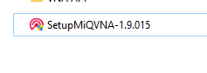

## Hardware connections

### VTC/PC

* 2 used connection (both USB Connection)
  + One connects to the Arduino will need an adaptor
  + The other connection to the VNA will need an adaptor

### Arduino

* 3 connections
  + Pc
  + Power will need to be connected to the 12-volt power supply to operate actuators this is connected as seen in the image below brown and blue wires. It’s connected by (+ to Vin and – to GND)
  + Actuator – refer to actuator section

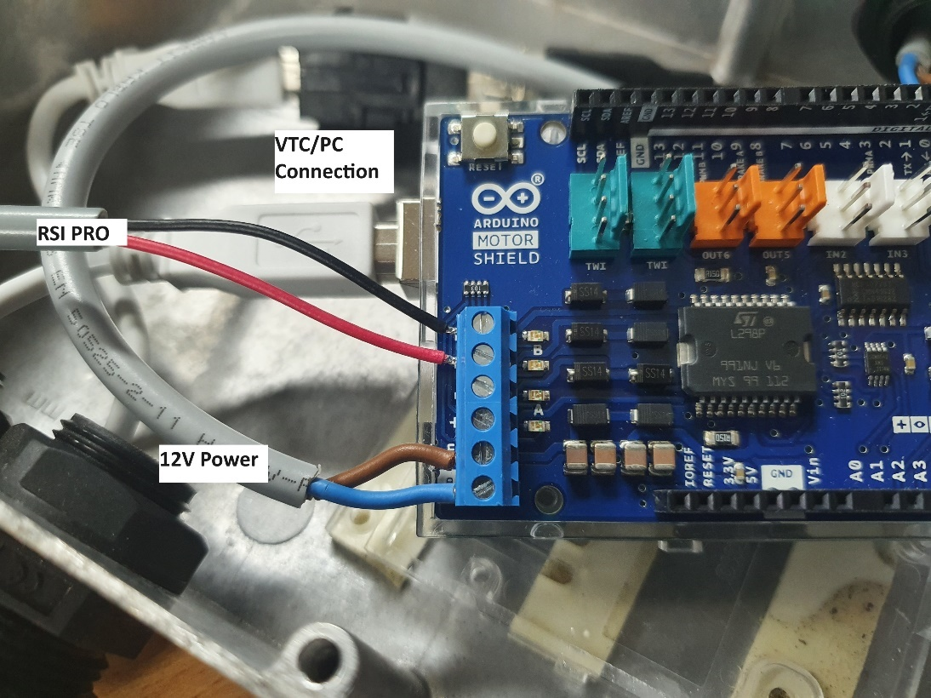

### VNA

* 2 connections
  + Power
  + Pc

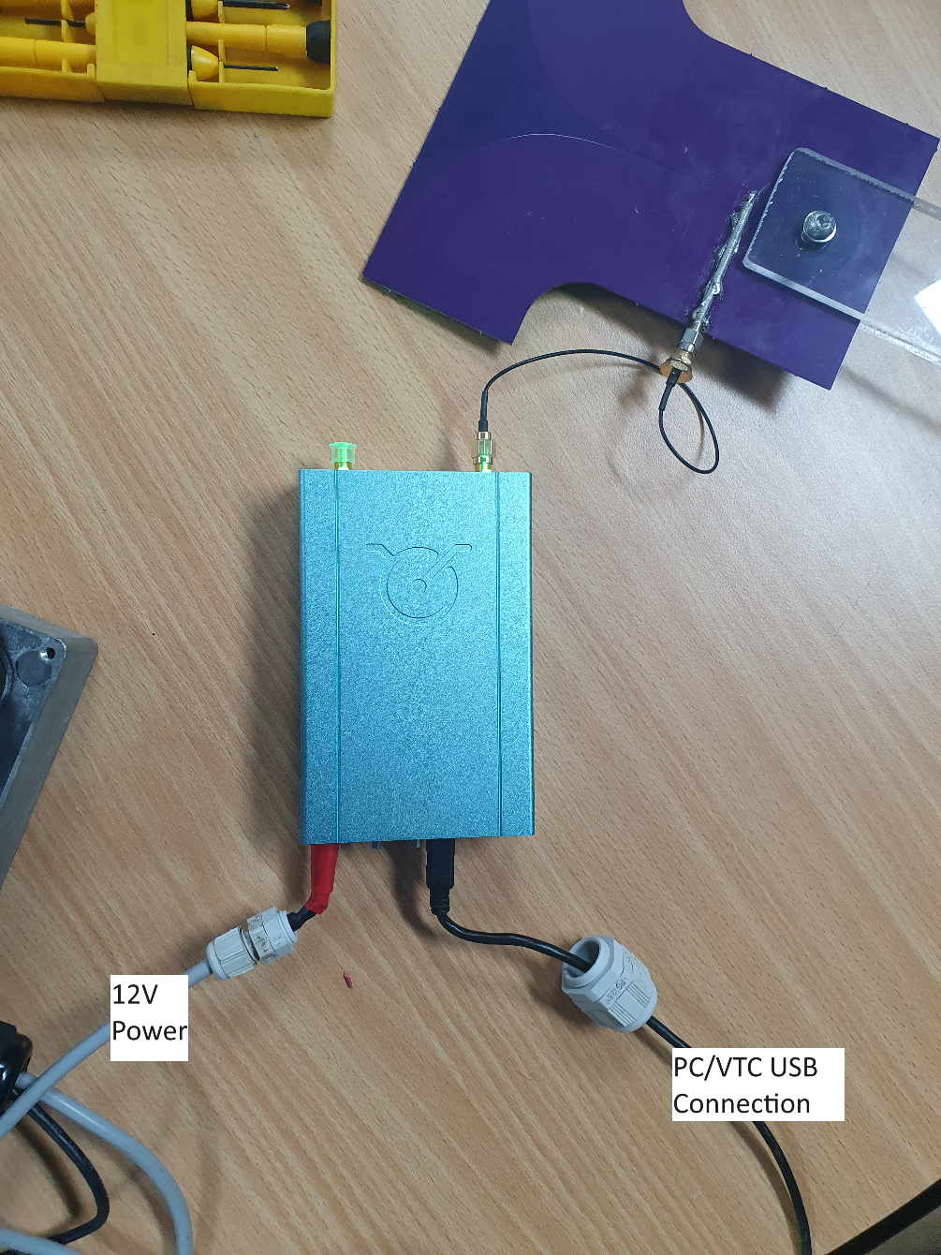

* Device is made up of multiple parts will need to connect these as well. Refer to above image

### Actuator

#### Actuonix

* 2 connections

#### RSI PRO

* 1 connection
  + The RSI PRO will need to be connected to the Arduino via one of the motor control pins (B in this case). In practice this is 2 wires connected to the Arduino (will be + to + and – to - | Red and black wires) as seen in the image below.

### Teltonika

* 1 connection
  + The VTC/PC will need to be connected to the same network however this should already be the case and therefore no connection will need to be made. However if not connect a usb to either the netgear or teltonika via one of the ethernet data ports.

## VNA Interface changes

### Download python

You may also need to install python on the new device if not already

[Download Python | Python.org](https://www.python.org/downloads/)

### VNA interface config file changes.

* If you run the vna interface (runserver.py files) you will be greeted by this error message as seen in the image below.
* You will need to update some of the configuration files to run the server on a new device.

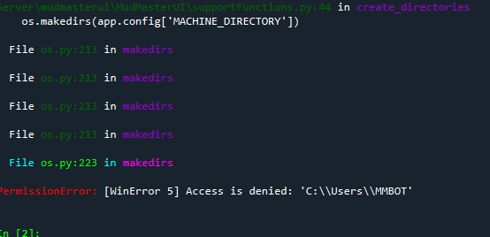

The following files can be found at

Megiq VNA Server\Python Server\mudmasterui\MudMasterUI

folder from the source files.

**Open config.py**

|  |  |
| --- | --- |
| MACHINE_DIRECTORY line 10 of config.py | Change the machine directory variable to the location you want the datafiles to be placed in. (this file will likely need to be synced with a SharePoint folders)    Below image file path has changed |
| Site line 19 of config.py | Change site to desired site.  Note that potential sites are found in Open config_site.py files. Used default or change to desired site. |

**Open configmachine.py**

|  |  |
| --- | --- |
| machineNumber line 3 of config_machine.py | * Change machine number to desired machine * And for 'vnaServerProcessPath' will need to find the MegiqVnaServer executable file path.   It should be in the same files collection of files that the python interface was in (Megiq VNA Server folder).     * Once updated |
| vnaServerProcessPath line 4 of config_machine.py |

**Open config_site.py**

|  |  |
| --- | --- |
| SITE_CONFIG line 53 of config_site.py | May need to update this file with a new site. Currently unsure of this. |

## Test Run

Give the server a test run. Should be able to run the server at this point.

* Connect sensor and Arduino via USB connection (one will connect to Arduino and the other to the sensor).
* Then run the runserver.py file using python found at Megiq VNA Server\Python Server\mudmasterui folder location.
* In or browser of choice goto <http://localhost:8080/home>
  + Should be a webpage at this location

## Helpful Trouble shooting information

|  |  |
| --- | --- |
| **Location of Teltonika connection variable**. (if teltonika cannot be found at 192.168.1.1 IP address then server will not be able to connect) | Found at  Megiq VNA Server\Python Server\mudmasterui\MudMasterUI\teltonikaSupportFunctions.py  File.  Change the variable DEVICE_IP in the image below (will be close to the top of the file). To dive new ip. |
| **Teltonika login information change.**  (if login username or password change on the device) | If password information for the teltonika is different then you will need to change the credential that the server uses to access the teltonika.  Found at  Megiq VNA Server\Python Server\mudmasterui\MudMasterUI\teltonikaSupportFunctions.py  File. Change the lines 37 and 38 seen in the image below to the correct username and password. |
| **Permission Error quick fix** | if you’re getting this error (in the image below) in the python console then there can be multiple issues.     * The first is another program such as Ardunio IDE is using the port, and you will need to close the application using the port. * The python interface also does not release ownership of the port even when closed (can occur when you restart the server) in this case unplug and reconnect the Arduino usb connection |
| Output of log datafiles location. | Megiq VNA Server\Python Server\mudmasterui\MudMasterUI\config.py |
| VNC Server connection variables | Megiq VNA Server\Python Server\mudmasterui\MudMasterUI\config.py |
| Log output configuration variables. | Megiq VNA Server\Python Server\mudmasterui\MudMasterUI\config.py |
|  |  |
|  |  |